|  |  |  |  |
| --- | --- | --- | --- |
| **F:\Learning bugs\Foundation Subjects\Dolly the Fly - Science.jpgLyng Primary School Knowledge Organiser** | | | |
| **Topic:** | **Science**  **Evolution and Inheritance** | Year 6 | Spring 1 |

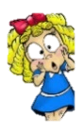

|  |  |
| --- | --- |
| **What Step On and Goldilocks words will I use?** | |
| **Spelling** | **Definition** |
| Adapt | Adjust to a new environment |
| Adaptation | A characteristic that helps an organism to survive in its habitat. |
| Archipelago | A large group of islands |
| Breed | To produce offspring. |
| Characteristic | A noticeable feature or quality. |
| Environmental | Linked with the surroundings of an organism. |
| Evolution | Small developments of a species which happen over 100s of years |
| Extinct | Having no living members. |
| Gene | A unit of inheritance passed from parent to offspring that controls characteristics. |
| Habitat | Where something lives. |
| Inherit | To be born with the same characteristic as a parent or grandparent. |
| Natural selection | The process where living things that are better adapted to their habitat survive and produce more offspring with those characteristics. |
| Offspring | The young produced by a living organism. |
| Population | A group of the same species living together. |
| Reproduce | Living things producing new versions of themselves. |
| Saddle-back | A shell, which is shaped like a saddle. |
| Species | A group of similar organisms that can be classified into the smallest group together. |
| Subspecies | a particular group within a species that has branched off usually due to geographic isolation. |
| Survival | Continuing to live. |
| Variation | Differences in characteristics between individuals within a species. |

**Notable scientists**

Charles Darwin

(1809-1882)

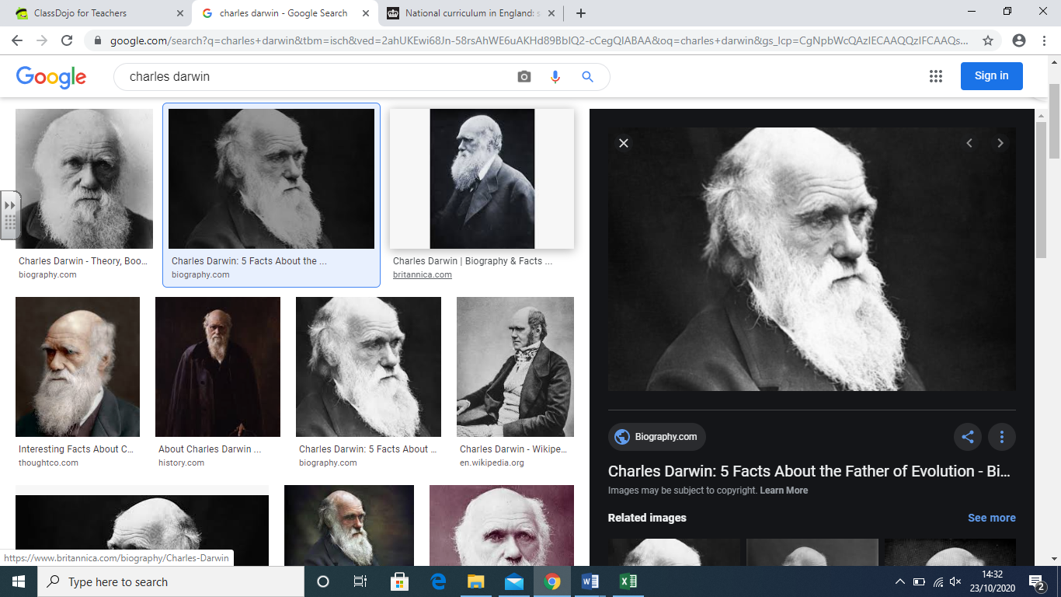

**What should I already know?**

This is a new topic for Year 6 children; however, children will have some knowledge of prehistoric humans from their Stone Age topic where they will have identified the similarities and differences between a prehistoric human and modern-day human.  
Building on what they learned about fossils in the topic on rocks in Year 3, pupils should find out more about how living things on earth have changed over time.

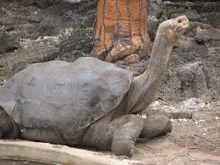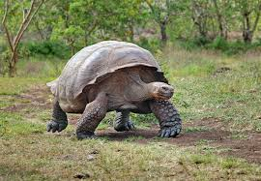

|  |
| --- |
| **Investigate!** |
| * Sort variation as environmental, inherited or a mixture of both. * Evaluate a method by recalling variables that were effectively kept the same and those that were harder to control. * Comment on the reliability of the results and the degree of trust. * Consider how evidence is used to form theories and the degree of trust the evidence offers. |

|  |
| --- |
| **Enquiry Questions** |
| * Why are there differences within a species? * What are the inheritance of characteristic in plants and animals? * Why is adaptation necessary? * How does natural selection affect population size? * How can we describe the theory of evolution? * What evidence can be used for evolution? |

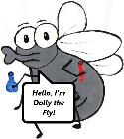

**What will I know by the end of the unit?**

|  |
| --- |
| Children will… |
| Studying patterns in humans and other species, children learn about characteristics that are inherited and those that are environmental. Through the eyes of Darwin and Wallace, pupils understand how observations lead to theories. By modelling finches’ variation and natural  selection, they begin to explain how species evolve and the role of fossil evidence that supports  this theory. |
| * Define and identify variation in organisms and recall that it is caused by inherited and environmental factors. * Recall that living things produce offspring of the same kind but are not normally identical to their parents. * Describe patterns of inheritance from parent to offspring in a given example or family tree. * Describe what an adaptation is; it cannot be chosen and is usually inherited. |
| * Describe key characteristics that would help an organism to survive and explain how an adaptation helps the organism to survive. * Explain how variation may affect survival within a population and recall what natural selection means. * Recall what evolution is, identify differences between a living thing and its ancestor and describe key steps in the evolution of a species. * Recall different types of evidence that can be used to explain evolution and describe methods that make scientists’ results or conclusions more trustworthy |

|  |  |  |  |
| --- | --- | --- | --- |
| **F:\Learning bugs\Foundation Subjects\Dolly the Fly - Science.jpgLyng Primary School Knowledge Organiser** | | | |
| **Topic:** | **Science**  **Evolution and Inheritance** | Year 6 | Spring 1 |

|  |  |  |
| --- | --- | --- |
| 1. What is a variation? | **S** | **E** |
| 1. Any similarity between individuals of a species. |  |  |
| 1. Any difference between individuals of a species. |  |  |
| 1. Any comparison between individuals of a species. |  |  |
| 1. Any individuals of a species. |  |  |

|  |  |  |
| --- | --- | --- |
| 1. An adaptation is… | **S** | **E** |
| 1. An inherited characteristic that helps an organism to survive. |  |  |
| 1. An inherited characteristic that stops an organism from surviving. |  |  |
| 1. An environmental characteristic that helps an organism to survive. |  |  |
| 1. An environmental characteristic that stops an organism from surviving. |  |  |

|  |  |  |
| --- | --- | --- |
| 2. Which of these is an example of just environmental variation? | **S** | **E** |
| 1. Hand span |  |  |
| 1. Blood type |  |  |
| 1. A scar |  |  |
| 1. Height |  |  |

|  |  |
| --- | --- |
| 1. What is an example of an adaptation for a polar bear? | |
| **S** |  |
| **E** |  |

|  |  |  |
| --- | --- | --- |
| 1. Which shows the correct order of the steps involved in natural selection? | **S** | **E** |
| 1. Gradual change – Advantages inherited – survival of the fittest – Variation. |  |  |
| 1. Gradual change – Survival of the fittest – Advantages inherited - Variation. |  |  |
| 1. Variation – Survival of the fittest – Advantages inherited – Gradual change. |  |  |
| 1. Variation – Advantages inherited – Survival of the fittest – Gradual change. |  |  |

|  |  |
| --- | --- |
| 1. What are the two causes of variation within a species? | |
| **S** |  |
| **E** |  |

|  |  |  |
| --- | --- | --- |
| 4. Which of these is an example of just inherited variation? | **S** | **E** |
| 1. Hand span |  |  |
| 1. Blood type |  |  |
| 1. A scar |  |  |
| 1. Height |  |  |